British Columbia Political Studies Association

2019 Conference, Langara College
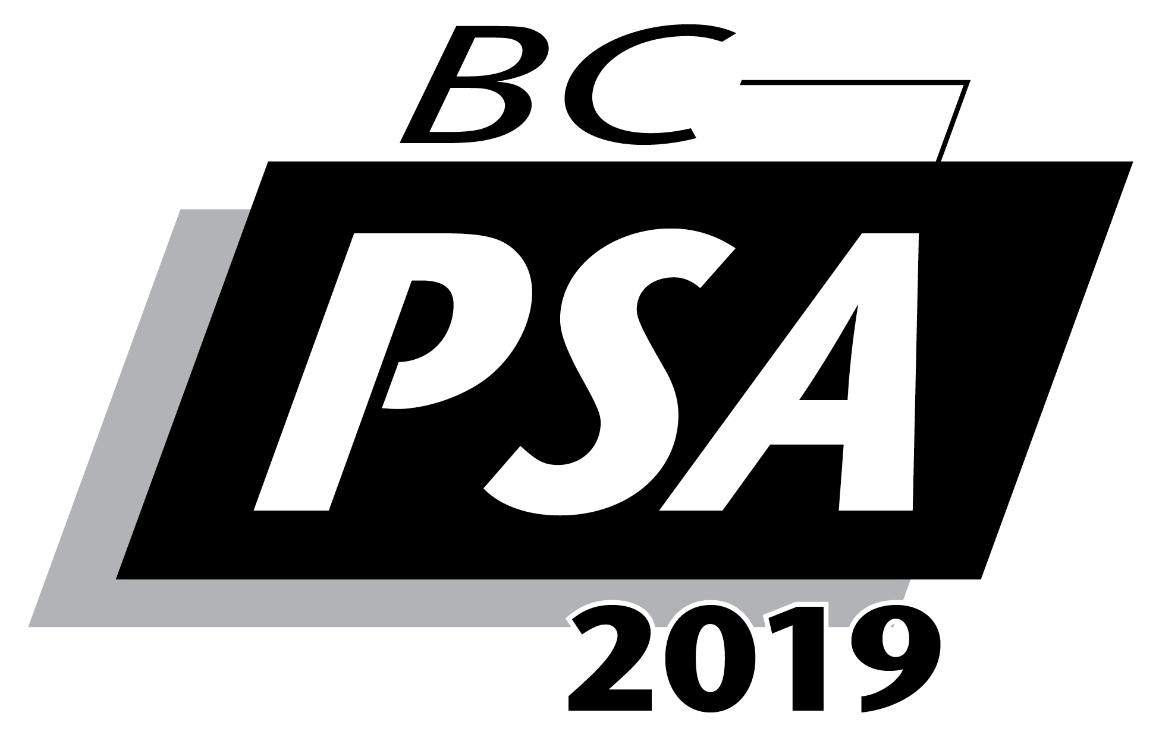

THURSDAY, MAY 2nd, 2019

Agenda-in-Brief

TIME
0800 -  0900 | Registration - Employee Lounge
0830 –  0850 | Opening Ceremonies – Employee Lounge
0900 –  1030 | I. International Relations  Rm. B-247 | II. Elections  Rm. B-248 | III. Theory  Rm. B-251
1030-1045 | Coffee Break – Employee Lounge
1045 –  1215 | IV. Local Government  Rm. B-247 | V. Social Movements  Rm. B-248 | VI. Comparative Politics: Asia  Rm. B-251
1215 –  1330 | Lunch  BCPSA Book and Essay Prizes  Employee Lounge
1330 –  1500 | VII. BCPSA Annual Business Meeting  Rm. B-247 | VIII. Theory  Rm. B-248 | IX. Politics and Gender  Rm. B-251
1500-1515 | Coffee Break – Employee Lounge
1515 –  1645 | Plenary Roundtable on Canadian Politics:  Populism in Canada: Past, Present, and Future  Lecture Theatre A-136b
1700 -  1800 | RECEPTION — Employee Lounge

FRIDAY, MAY 3rd, 2019

TIME
0800 –  0900 | Registration – Employee Lounge
0830 –  1200 | BC POLITICAL SCIENCE ARTICULATION MEETING  Rm. A-253
0900 –  1030 | I. Public Policy: Security Intelligence  Rm. B-247 | II. Local Government  Rm. B-248 | III. The Crown in Canada  Rm. B-251
1030-1045 | Coffee Break – Employee Lounge
1045-  1215 | IV. Canadian Politics  Rm. B-247 | V. International Relations  Rm. B-248 | VI. Theory  Rm. B-251
1215 –  1300 | BC Political Science Articulation Lunch  Employee Lounge
1300 –  1400 | Keynote Speaker: Dr. Dennis Pilon (York)  Lecture Theatre A-136b
1400 –  1530 | VII. BC Politics Roundtable  Rm. B-247 | VIII. Canadian Anti-Terrorism  Rm. B-248 | IX. BCPSA / Articulation Roundtable on the Indigenization of Political Science  Lecture Theatre A-136b
1530-1545 | Coffee Break – Employee Lounge
1545 –  1715 | X. Canadian Public Policy  Rm. B-247 |  | XI. BCPSA / Articulation Roundtable on Teaching Millennials  Lecture Theatre A-136b

